Orators Report
on the 27th degree
KNIGHT of the SUN
or PRINCE ADEPT
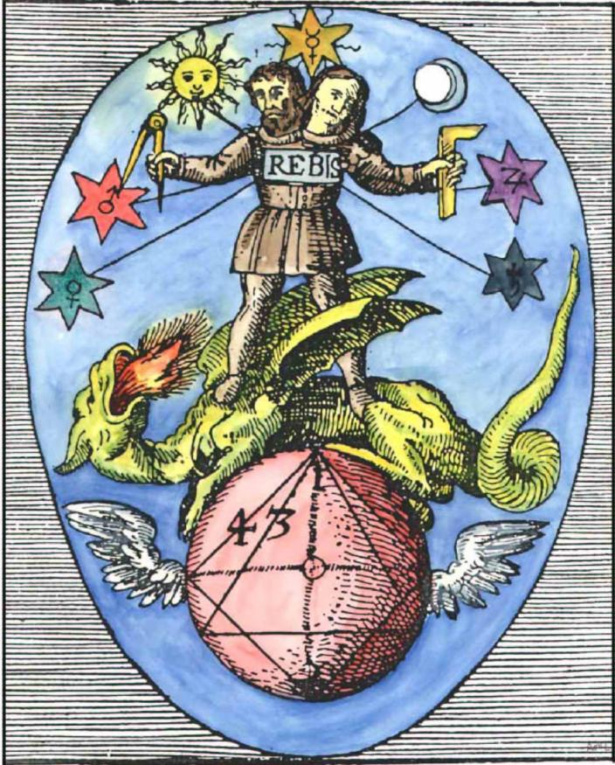
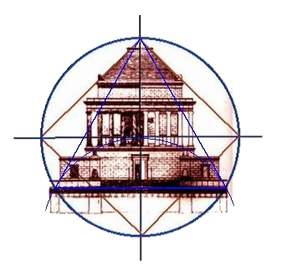
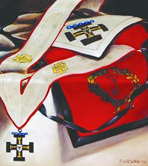
Aug 1, 2012

Bremerton Valley of the Scottish Rite
The Legend and History: It has been surmised that some Rosicrucian or Hermeticist Alchemists introduced their symbols, having philosophical and religious meanings, to the Craft-Masons, and they adopted and used them many centuries before the formal establishment (1717) of "Speculative Masonry". However, Albert Pike asserts that the "manually-labouring illiterate Masons of Scotland or England … were not Alchemists, Hermericists or Rosicrucians, and had no use for, nor could understand and comprehend such symbols, or the doctrines concealed in them"… "If such symbols were used in Masonry at all, before 1717, their religious and philosophical explanations were known only to those addicted to philosophical speculation, and the symbols must have had other explanations for the labouring men." As these symbols, common to Masonry and Hermeticism, were certainly used by the latter, long before they made their appearance in the Masonry, it is more likely that men such as Elias Ashmole, a Freemason, introduced Hermetic symbolism into Speculative Freemasonry in the late 17th and early 18th century.
The Setting: The presiding Officer, Father Adam, wears a brown robe, symbol of the earth from whence he came. The seven angels (MALAKOTH) acting as teachers are Cassiel, Sachiel, Zamael, Michael, Hanael, Raphael, and Gabriel. This degree differs from those previously presented. The others represented Lodges or Chapters that related stories from history or mythology. This Degree has no Candidate and all present are asked to participate fully in the instruction. The doctrine of this Degree is chiefly derived from the Kabbalah, similar to that which was taught by the Hermetic Philosophers who wrote on Alchemy.
The Ritual: Since there is no Candidate, the ritual consists of lectures on aspects of symbolic masonry by each of the officers. The ritual ends with a charge to all to pursue truth and perform Masonic labor. Masonic labor is to learn - and teach others.
The Lectures: Freemasonry has been defined as a beautiful system of morality, veiled in allegory and illustrated by symbols. The purpose of this degree is to introduce you to the nature of symbols. A doctrine ascribed to a messenger of God, "As above, so below" means that the material world and all it contains is a pale reflection of the spiritual world above. By analogy, a symbol is a pale reflection of the thing it symbolizes. As an example, the Latin word for apple is malum (may-lum) spelled m-a-l-u-m, and the Latin word for 'evil' is (mahl-um), is also spelled the same way. This provided an opportunity for a play on words; the apple being used as the symbol of Adam eating the apple of good and evil.
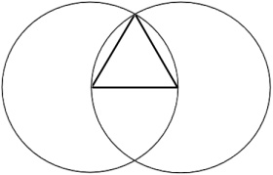
Cassiel's lecture: symbols in geometry. The Grecian geometer Euclid used the rule and compasses to demonstrate the construction of an equilateral triangle. The Pythagoreans regarded the equilateral triangle as the most profound symbol of God. In each of the examples, repeated over and over, are "earth and heaven", "physical and spiritual" meanings in the symbols.
Sachiel's lecture: the mystery of numbers. Pythagoras knew that numbers describe reality, e.g. Pi. Many cultures, including the ancient Romans, Greeks, and Hebrews did not have special characters for numbers. They used letters of their alphabet to express numbers. The natural result is that every word of their language had a numerical value. This method of numerical equivalence is called gematria, whose root is the same as geometry. Such methods of interpretation were part of the development of an entire school in orthodox Judaism, called Kabbalah.
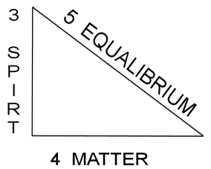
Some numbers have a long tradition of mystical association. The number seven should readily come to mind. The spiritual world and God can be represented by the number three, from the belief that there were three essential attributes of God. Since 4 represented the physical world elements of the ancients: earth, air, fire, and water and 3 represented the spiritual world, 7 represented the whole.
Zamael's lecture: the synthesis of geometry and numbers. Particularly instructive is the right Triangle of Pythagoras: 3, 4, 5: three: spirit, four: matter, and five equilibrium.
Another example: the numerical value of the 5 Hebrew letters of God, ALHIM can be arranged as 3.1415, the approximation of Pi.
As an example of how number symbolism expressed by letter is used in Symbolic Lodge Masonry, we have the instance of the symbols of Chalk, Charcoal, and Clay. The Hebrew words for chalk, charcoal and clay sum to the same value as the name for Solomon.
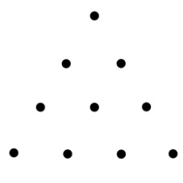
Michael's lecture: the mystery of the Pythagorean Tetractys. The Tetractys, is the holiest symbol of the Pythagoreans. Ten points arranged as a pyramid in 4,3,2,1 order. From this simple figure of ten points forming an equilateral triangle emerge many interesting forms. By medieval times the Tetractys was being used as a template for the writings of the Tetragrammaton, the four letter name of God (YHVH ) given to Moses on Mt. Sinai.
Hanael's lecture: religious symbolism. The primitive fish symbol of Christianity is composed of a form created by two partial circles overlapped. This not coincidental, as shown by the statue of Jesus in a vesica piscis (wes-ih-kah pis-kis) at Chartres Cathedral in France. Of greater familiarity, if not importance, as a symbol of Christianity is the cross. The vertical line representing spiritual things and the horizontal line representing earthly matters. Another example: the Hebrew letter shin is formed of three tongues of flame united in a single letter, indicating composite unity, like the equilateral triangle and its three sides. Thus, both are used as hieroglyphs or symbols for God.
Raphael's lecture: symbols of the Hermetic philosophers. The alchemists sought to read the symbols of the Book of Nature and so contributed many of their discoveries to the symbolism of Freemasonry. The 18th degree, titled "Knight of the Rose Croix" is particularly noteworthy for its references to alchemy. More on this subject is available in the article SCOTTISH CHEMISTRY , Survey of Alchemical Symbols … by Russell R. Boedeker, 32º KCCH at website: http://www.freemasons-freemasonry.com/alchemy_freemasonry.html.
Gabriel's lecture: Often an idea is symbolized by an entire sentence or picture. On the cover we see an ancient hermetic illustration replete with symbols taken from the Book of Nature and since borrowed by Freemasonry. It is called the Rebis. Note the point within the circle, the equilateral triangle, and the square. The winged globe symbolizes eternity. Note our House of the Temple architectural relationship. An illustration as complicated as the Rebis cannot be fully explained here, further contemplation is encouraged.
Summary: Light is an ancient symbol of truth because it reveals the world to us. This Degree called "Knight of the Sun or Prince Adept". It is called "Knight of the Sun" because the Sun is the source of the material light that reveals nature to us. And, it is called "Prince Adept" because those who can read the symbols of the Book of Nature are Princes among Masons, and Adepts among men. You are charged to pursue truth and to learn - and teach others.
DUTIES include: Be a lover of wisdom; keep your promises.
IMPORTANT SYMBOLS: Rebis, Solomon’s Seal, Right Triangle, Tetractys
Adapted from Rex R. Hutchen’s book A Bridge to Light. Other Sources: 1. Arturo de Hoyos, Scottish Rite Ritual Monitor & Guide, 2nd ed., 2009, 2. Arturo de Hoyos, Albert Pike's Esoterika: The Symbolism of the Blue Degrees of Freemasonry' 1st ed. 2005. 3. Russell R. Boedeker, "SCOTTISH CHEMISTRY, Survey of Alchemical Symbols in the LOP.

